**Save Game**

We will save the bullets fired to a file in FPS template.

Create save game BP

Create an integer variable in player (since bullet count is integer)

Add BP to increment Bullet variable when fired

And print string as well to print the bullet variable

Add in player character following BP to load and create save game object

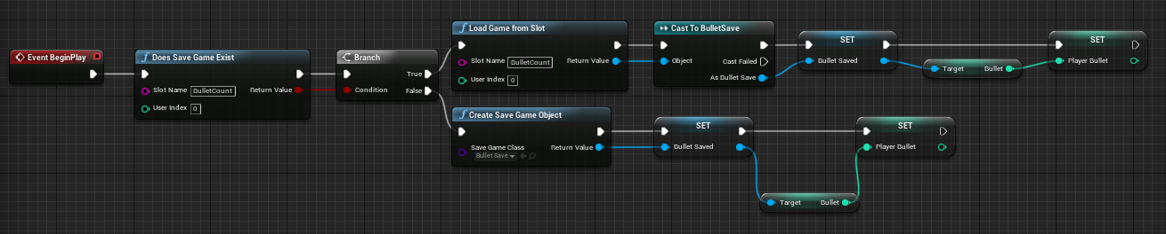

Add following BP to save the bullet count

